Mitigating Data Breaches

A Capstone Project
Presented to the Faculty of the
College of Information Technology Education
PHINMA University of Iloilo

In Partial Fulfillment
of the Requirements for the degree
Bachelor of Science in Information Technology

By:
Chrislyn A. Limo
Riben Clark Gaspar
Milo B. Yasa Jr.

October 2025

Approval Sheet
In partial fulfillment of the requirements for the Bachelor of Science in Information Technology, this Capstone Project entitled "Mitigating Data Breaches” prepared and Submitted by Chrislyn A. Limo, Riben Clark Gaspar and Milo B. Yasa Jr. who are hereby recommended for corresponding final evaluation.

Gerald Uy
Adviser

Approved by the Panel of Evaluators with a grade of PASSED

Dr. Arnold M. Fuentes, Ph. D, MPA, MMIT
Chairman

Chrislyn A. Limo
Riben Clark Gaspar
Milo B. Yasa Jr.
Member

Accepted in partial fulfillment of the requirements of the degree Bachelor of Science in Information Technology

Seth dA. Nono, MSCS
CITE, DEAN

ACKNOWLEGEMENT

We, the researchers, would like to express our deepest gratitude to all the individuals and institutions who have extended their support and guidance in the successful completion of our capstone project, “Mitigating Data Breaches”.
First and foremost, we thank Almighty God for granting us wisdom, strength, and perseverance throughout this journey.
Our heartfelt appreciation goes to our adviser, Dr. Arnold M. Fuentes, Ph.D, MPA, MMIT, and Sir Gerald Uy, for their invaluable guidance, constructive feedback, and encouragement, which greatly contributed to the success of our project.
We are sincerely grateful to PHINMA University of Iloilo and the CITE Department for providing us with the resources and opportunities needed to accomplish this study.
We also extend our thanks to the people who eagerly answered our survey for their cooperation in providing the necessary information and data for our research. Their insights have been invaluable in shaping our findings and ensuring the accuracy of our conclusions. We appreciate their time and effort, which significantly contributed to the success of this project.
Finally, we are deeply thankful to our families, friends, and classmates for their unwavering moral, emotional, and financial support throughout the development of this project.
This achievement would not have been possible without your collective effort and dedication. Thank you very much.

Abstract

The growing dependence on digital platforms for financial transactions, communication, and data storage has raised organizational vulnerability to cyberattacks and data breaches. This study presents the development of a desktop-based cybersecurity application designed to mitigate such threats through advanced protective measures, including encryption, monitoring the files, and preventing possible data breaches. By employing strong encryption algorithms and continuously monitoring system activity, the application ensures that potential threats are identified and addressed before significant damage occurs. The system enables real-time threat detection and response while ensuring compliance with privacy regulations such as the Philippine Data Privacy Act and the General Data Protection Regulation (GDPR). The research follows the System Development Life Cycle (SDLC) framework, supported by data gathered from surveys, interviews, focus groups, and document analysis. Key features of the application include automated breach alerts, secure user authentication, and detailed audit reporting to assist in incident response. Ultimately, the project aims to enhance organizational security, strengthen digital resilience, and provide effective tools to safeguard sensitive information against evolving cyberthreats, especially data breaches.

TABLE OF CONTENTS

Title page -------------------------------------------------i

ApprovalSheet-----------------------------------------------ii

Acknowledgement---------------------------------------------iii

Abstract----------------------------------------------------iv

Table of Contents-------------------------------------------v

List of Figures---------------------------------------------vi

CHAPTER I

Introduction-------------------------------------------------1
Background of the Study--------------------------------2
Statement of the Problem-------------------------------3
Objectives of the Study--------------------------------4
Significance of the Study------------------------------4-5
Scope and Limitation-----------------------------------6

CHAPTER II

Literature Review-----------------------------------------------------7-8-9
Overview----------------------------------------------10
Traditional VS Modern System--------------------------10
Technology Use----------------------------------------11
Case Studies-------------------------------------------11-12

CHAPTER III
Methodology------------------------------------------------12
Research Design-----------------------------------------12
Model Use-----------------------------------------------13-14
Data Flow Diagram---------------------------------------14
Entity Relationship Diagram-----------------------------15-16

CHAPTER IV

Result and Discussion-------------------------------------16
System’s Features---------------------------------------17-18
Implementation Challenges-------------------------------18-19
User Feedback—------------------------------------------19-22
Comparison to other Systems ----------------------------22-23

CHAPTER V

Conclusion and Recommendation-----------------------------23
Conclusion--------------------------------------------24
Recommendation----------------------------------------24-25
Final Thoughts----------------------------------------25

Appendices-----------------------------------------------25-32
Screenshots----------------------------------------------33
Curriculum Vitae-----------------------------------------33-37
Grammarian Certificate-----------------------------------37

LIST OF FIGURES

Figure Context- Level Data Flow Diagram

Page 14

Figure Entity Relationship Diagram

Page 15
Figure User Feedback Evaluation Graph

Page 21

Chapter 1

Introduction to the Study
The goal of this project is to implement and design a desktop-based application specifically for mitigating data breaches. In the modern-day digital world, data has become one of the most important assets for both individuals and organizations. However, greater dependence on digital storage and file management had equally increased incidents of unauthorized access and data breaches. A data breach involves unauthorized access, modification, or disclosure of sensitive or confidential data, often causing financial losses, data corruption, and loss of trust in digital systems. While most operating systems came with a file explorer, these products lacked key security capabilities such as encryption, activity logging, and real-time monitoring to protect files against unauthorized actions.
To fix these problems, the researchers have developed a desktop-based application called “Mitigating Data Breaches” to enhance data security and mitigate risks associated with files. A suite of security functionalities, such as file tracking, encryption and decryption, authentication of users, logging activity, and backup management, was integrated into this system. This system combined all the above functions in a single application that offered a secure, file management environment for protecting data from unauthorized access and accidental loss without sacrificing usability in day-to-day file operations.
The concepts of confidentiality, integrity, and availability of digital information were encapsulated in the Mitigating Data Breaches System. The system assured that users could securely manage, track, and recover their files through its monitoring, encryption, and logging mechanisms. This project provided a practical and reliable solution to mitigate breaches within a local desktop environment and thus contributed to the betterment of data protection practices.

Background of the Study
Data breaches have become one of the most persistent challenges in the sphere of information security. With computers becoming major repositories and processors of important data, the associated risks of unauthorized access, accidental deletion, and file corruption also increased. Many users and organizations relied on native file explorers to handle data, but such file explorers did not offer protection mechanisms related to encryption, monitoring, and control of user access. Without these features, files were highly susceptible to intrusion, tampering, or permanent loss.
This scenario calls for the use of a system that keeps data confidential, maintains its integrity, and ensures its availability. In response to such needs, the researchers developed a system that integrated real-time file monitoring, encryption, backup, and log scanning. The system monitored all file activities, including file creation, modification, deletion, and access, enabling early detection of unauthorized actions. Besides this, the encryption and backup modules ensured that sensitive files remained protected and recoverable during security incidents or accidental losses.
The Mitigating Data Breaches System was a comprehensive tool for strengthening local file security by combining the aforementioned features. It was designed to let users manage their files efficiently while having all operations recorded and protected. By placing great emphasis on automation and accountability, the system reduced vulnerabilities within digital file handling and supported the increasingly strong demand for cybersecurity measures at both personal and organizational levels.

Statement of the Problem
This study addressed the issue of data breaches that threatened the confidentiality, integrity, and availability of digital files. Unauthorized access, accidental deletion, and weak file protection features in existing file management systems increased the risk of sensitive information being exposed. Without proper monitoring, backup, and encryption mechanisms, users remained vulnerable to data loss and cyber threats.

This project implemented advanced security features such as file monitoring, encryption, backup, and log scanning to help detect, prevent, and mitigate data breaches. To achieve this, the study sought to answer the following key questions:

- How could file activities such as creation, modification, deletion, and encryption be effectively monitored and logged to detect and prevent unauthorized access?

- How could backup, recovery, and encryption features be integrated into a desktop application to minimize data loss and protect sensitive files?

- How could a log scanning module be designed to provide administrators and users with actionable insights for the early detection of breach attempts?

By answering these questions, the study aimed to strengthen digital defenses, reduce vulnerabilities, and provide a secure and reliable desktop environment for file management.

Objectives of the Study

This study focused on the development of a desktop-based application entitled “Mitigating Data Breaches.” The system was designed to address the escalating risks of unauthorized access, accidental data loss, and weak security practices in file management. With the increasing threats to digital information, there was a pressing need for a system that enhanced the confidentiality, integrity, and availability of files.
The primary objective of this study was to design and develop the Mitigating Data Breaches System, which aimed to strengthen file security through monitoring, encryption, backup, and log scanning. Specifically, the study sought to:

- Identify vulnerabilities in file management that expose sensitive data to breaches and propose solutions through integrated monitoring and backup.
- Implement encryption and decryption mechanisms to ensure that only authorized users can access sensitive files.
- Provide real-time monitoring and logging tools that record user activities and support the early detection of breach attempts.
- Develop an automated and manual backup feature that safeguards files against accidental loss or corruption.
- Design a secure file explorer environment where users can create, move, modify, and delete files while ensuring accountability through logs.

Significance of the Study
This study was significant because it developed a desktop-based application entitled “Mitigating Data Breaches,” which addressed the growing problem of unauthorized access, accidental data loss, and vulnerabilities in file management. The system incorporated file monitoring, encryption, backup, and log scanning, which traditional file management tools often lacked. By doing so, it offered a more secure and accountable environment for handling sensitive digital files.
The study was important to students and researchers because it served as an academic reference for future investigations concerning data security, file monitoring, and breach prevention. It expanded the body of knowledge in the field of cybersecurity and demonstrated how a desktop-based solution could be applied to safeguard information assets.
For organizations, the system provided a practical tool to protect confidential files from data breaches while ensuring accountability and compliance with data privacy regulations. By recording user activities and integrating security features, the application supported organizations in maintaining the confidentiality, integrity, and availability of their data.
The study was also relevant to general users, as it offered a user-friendly yet secure platform for managing files. Through its backup, monitoring, and encryption capabilities, the system minimized risks of data loss and unauthorized access, making it useful for individuals handling personal or professional files.
Lastly, the project held value for IT practitioners, as it illustrated how theoretical cybersecurity concepts could be applied in practice. The integration of monitoring, backup, and encryption demonstrated a framework for mitigating data breaches in real-world file management scenarios.

In summary, this study was significant because it provided both academic and practical contributions. It bridged the gap between usability and security, offering a solution that strengthened data protection while addressing the persistent threat of breaches in a desktop computing environment.

Scope and Limitation
The scope of this study focused on the design and development of a desktop-based application entitled “Mitigating Data Breaches.” The system was specifically created to monitor file activities such as creation, modification, deletion, movement, and encryption. It included a built-in file explorer to allow secure and efficient file management. The application was also developed with a backup and recovery module to minimize risks of data loss and ensure file availability in case of accidental deletion or breaches. Furthermore, the system integrated file encryption and decryption to protect sensitive information from unauthorized access. A scanning feature was included to generate logs and provide users or administrators with insights into file activity, allowing early detection of potential breaches.
The study was limited to the functions directly related to desktop file management and security. The application operated only within the local computer environment and did not extend to cloud-based platforms, mobile devices, or network-wide security systems. The monitoring feature was restricted to activities performed within the system’s file explorer and did not include files accessed outside the application. Likewise, the backup and recovery module was designed only for files managed within the application and did not guarantee protection against hardware failure or external attacks beyond the system’s control. Additionally, while the system offered encryption and log scanning, it did not employ advanced technologies such as artificial intelligence, machine learning, or multi-factor authentication, as these were outside the project’s scope.

In summary, the study concentrated on mitigating data breaches through a desktop-based security system that combined monitoring, file exploration, backup, encryption, and log scanning. However, its coverage was limited to local file management and did not address broader aspects of enterprise-level or network-based cybersecurity.

Chapter 2

Literature Review
This chapter presented related studies and literature that supported the development of the Mitigating Data Breaches System. The review focused on research involving file monitoring, encryption, backup, authentication, and breach mitigation. These studies provided insights into how technological solutions could enhance data protection and maintain the confidentiality, integrity, and availability of digital information.

File Monitoring and Logging Systems
Monitoring and logging played an essential role in detecting unauthorized file access and maintaining accountability in data management systems. According to Vanmuri (2005), continuous monitoring of file activities helped detect anomalies such as unauthorized file creation, modification, or deletion. Similarly, Alhassan, Sarpong, and Boateng (2021) explained that detailed log auditing improved visibility into user actions and strengthened digital forensics. In line with these studies, the Mitigating Data Breaches System included a real-time file monitoring and log scanning feature that recorded all file activities to identify and prevent potential breach attempts.

File Encryption and Decryption
Encryption had long been a fundamental technique for securing data from unauthorized access. Stallings (2019) stated that encryption transformed readable information into an unreadable form that could only be accessed using a decryption key, ensuring that sensitive data remained confidential. Likewise, Kozachok, Kozachok, and Spirin (2022) introduced an encryption algorithm that improved file protection by automating the detection and encryption of sensitive files. Following these principles, the Mitigating Data Breaches System implemented encryption and decryption modules that safeguarded files and restricted access only to authorized users.

Data Backup and Recovery
Effective data backup and recovery mechanisms ensured data availability and resilience against accidental loss or corruption. Zhao, Wang, and Liu (2023) emphasized that automated and hybrid encryption-based backup systems increased recovery speed and enhanced data integrity. In a similar manner, Vanmuri (2005) discussed the importance of redundancy and data preservation in networked systems. The proposed system adopted both automated and manual backup functions to protect files and guarantee that users could restore data in the event of breaches or system failures.

User Authentication and Access Control
Authentication and access control were crucial in maintaining data confidentiality. Tan and Nguyen (2022) found that integrating multi-level authentication and role-based access control significantly reduced unauthorized access. Similarly, Moura Vicente and Casimiro (2020) highlighted that user verification mechanisms strengthened overall data protection by ensuring that only legitimate users could access sensitive files. The Mitigating Data Breaches System applied authentication key files and authorization processes to restrict system access and maintain a secure working environment.

Breach Detection and Mitigation
Detecting and mitigating data breaches in real time helped organizations prevent further damage and data exposure. Algarni, Thayananthan, and Malaiya (2021) presented a quantitative framework for assessing cybersecurity risks, emphasizing the need for proactive breach detection mechanisms in data systems. Abubakar and Bello (2023) also demonstrated that combining behavioral analysis with automated alerts improved early breach identification. Inspired by these studies, the Mitigating Data Breaches System incorporated a log scanning feature capable of detecting irregular file activities that may indicate breach attempts.

References:
Abubakar, A., & Bello, I. (2023). Automated breach detection using behavioral analysis in local systems. International Journal of Cybersecurity Research, 9(2), 112–121.
Algarni, A. M., Thayananthan, V., & Malaiya, Y. K. (2021). Quantitative assessment of cybersecurity risks for mitigating data breaches in business systems. Applied Sciences, 11(8), 3678.
Kozachok, A. V., Kozachok, V. I., & Spirin, A. A. (2022). An encrypted file detection algorithm. Automatic Control and Computer Sciences, 55(8), 1121–1128.
Moura Vicente, D., & de Vasconcelos Casimiro, S. (2020). Data protection in the Internet. Springer.
Stallings, W. (2019). Cryptography and network security: Principles and practice (8th ed.). Pearson Education.
Tan, L., & Nguyen, P. (2022). User authentication and access control mechanisms in secure file systems. Computing and Security Review, 10(1), 54–63.
Vanmuri, P. (2005). Network security and management. Firewall Media.
Zhao, J., Wang, Y., & Liu, X. (2023). Intelligent data backup and recovery using hybrid encryption techniques. Journal of Computer Security and Applications, 48, 105932.

Overview

Mitigating data breaches has been one of the most critical challenges in the digital era, as organizations and individuals increasingly rely on electronic platforms for data storage and file management. Cybersecurity threats, including unauthorized access, file tampering, and accidental data exposure, have been rising due to both external attacks and insider misuse. Previous studies emphasized that file-level protection was often overlooked, even though it played a vital role in safeguarding sensitive information. Cybersecurity research consistently pointed out that strategies such as encryption, backup, file monitoring, and activity logging were necessary to reduce vulnerabilities and enhance accountability within organizations. This study sought to build upon these foundations by exploring a desktop-based system that integrated these features to mitigate risks of data breaches.

Traditional vs. Modern System

Traditional approaches to data protection had primarily relied on external defenses, such as firewalls and antivirus software, which mainly focused on preventing intrusions at the network level. While these measures provided an important first line of defense, they were often insufficient in addressing breaches that occurred at the file or user level. For instance, unauthorized deletion, modification, or transfer of files within a system could occur without being detected by traditional security tools.
Modern systems, on the other hand, have shifted toward proactive and multi-layered security frameworks. File monitoring tools, encryption mechanisms, and automated log scanning became essential in ensuring accountability and reducing vulnerabilities. Unlike traditional defenses, modern systems integrated features such as detailed activity logs, real-time scanning, and secure backup solutions, enabling organizations to detect and respond to potential breaches more effectively. As cyber threats grew in sophistication, modern systems emphasized user-level accountability and data resilience, making them more adaptive to evolving risks.

Technology Use

Several technologies have been widely adopted to strengthen defenses against data breaches. Encryption was one of the most prominent methods, ensuring that sensitive files remained inaccessible to unauthorized individuals. Advanced encryption standards such as AES-256 have been extensively applied in securing financial, medical, and organizational data. Alongside encryption, monitoring technologies were increasingly used to track file activities such as creation, modification, movement, and deletion, providing a transparent record of user interactions with sensitive data.
Backup and recovery systems also played a crucial role by ensuring data availability even in cases of breaches, system failures, or accidental loss. Log scanning tools, often enhanced by automated detection systems, allowed administrators to identify patterns of suspicious activity before they escalated into major security incidents. Studies further highlighted the importance of integrating these technologies into unified systems, as fragmented solutions often left gaps that attackers could exploit.

Case Studies

Case studies in the field of cybersecurity demonstrated the consequences of insufficient file-level protection. Vemuri (2005) highlighted that privilege escalation and weak monitoring mechanisms often led to unauthorized access and data manipulation. Algarni et al. (2021) found that poor authentication practices and lack of activity logging contributed significantly to breaches, leaving organizations unable to trace the source of malicious actions. Smith and Brown (2020) reported that organizations implementing strong encryption protocols, such as AES-256, had successfully reduced risks of unauthorized data exposure, particularly in financial and healthcare sectors.
Another case study by Johnson et al. (2019) emphasized the role of proactive monitoring and scanning tools in detecting suspicious behavior before it could cause severe damage. Furthermore, Davis (2021) pointed out that organizations failing to comply with data protection regulations, such as the General Data Protection Regulation (GDPR) and the Philippine Data Privacy Act, not only faced legal and financial consequences but also suffered from reduced consumer trust. These studies collectively demonstrated that integrating file monitoring, encryption, backup, and log scanning into a single desktop application could significantly mitigate data breach risks and enhance organizational resilience.

Chapter 3

Methodology
The chapter addressed the methodology and development processes that were engaged in developing the Mitigating Data Breaches System. In essence, the project set out to design and implement a desktop-based security application for monitoring, encrypting, and securing files against unauthorized access and data breaches. Its methodology included a research design, a system development model, techniques of data collection, and the tools used throughout the development process.
Research Design

The study employed a developmental research design that focused on designing and implementing a desktop application aimed at mitigating data breaches. The developmental design was appropriate since the primary goal of the study was to create a working system rather than conduct experimental comparisons. The researchers followed the principles of the Agile methodology, which emphasized iterative development, stakeholder collaboration, and incremental delivery of features. Through this approach, the application was developed in cycles or sprints, ensuring that feedback from testing and evaluation was integrated into each iteration.

Model Used

The study adopted the Agile Software Development Life Cycle (SDLC) as its development model. This approach emphasized adaptability, stakeholder collaboration, and the incremental delivery of functional components. The development process followed the key Agile stages:
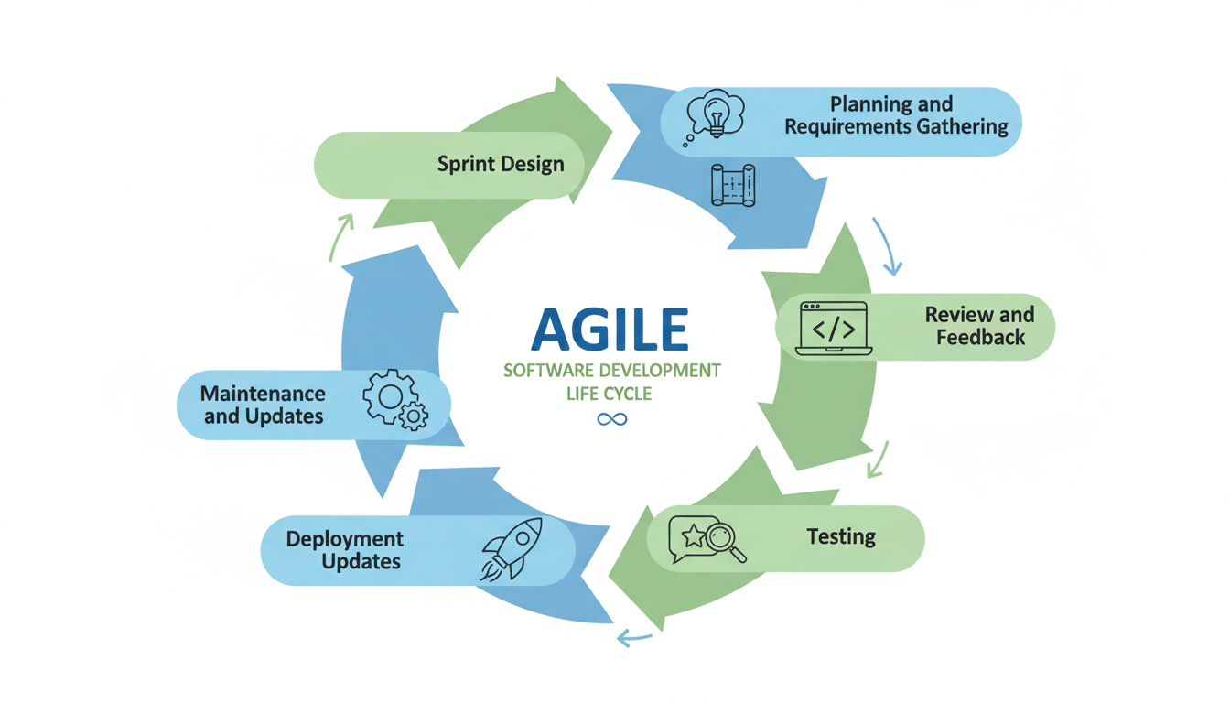

Planning and Requirements Gathering
The researchers identified potential system vulnerabilities, functional requirements, and compliance needs through stakeholder consultations and analysis of existing data protection frameworks.

Sprint Design
System features, including file monitoring, backup and recovery, encryption and decryption, secure file exploration, and log scanning, were distributed into sprints to ensure focused and manageable development.

Development
Each sprint produced a working increment of the application, which was developed using secure programming practices to minimize vulnerabilities and strengthen resistance to data breaches.

Testing
Continuous testing was conducted throughout and after each sprint. This included functionality checks, vulnerability scanning, penetration testing, and performance evaluation to ensure system reliability and security.

Review and Feedback
At the end of each sprint, the developed increment was demonstrated to stakeholders for evaluation. Their feedback guided improvements and refinements in subsequent iterations of the system.

Deployment
A stable version of the system was deployed after the final sprint, ensuring that all core features were integrated and ready for use within the target environment.

Maintenance and Updates
Following deployment, the system was subject to continuous maintenance and updates. These updates addressed newly discovered vulnerabilities, incorporated user feedback, and enhanced the system’s security mechanisms against evolving cyberthreats.

The adoption of the Agile model ensured that the system was developed in a flexible, iterative manner, allowing the researchers to refine its features in response to emerging requirements and the dynamic nature of cybersecurity threats.

Data Flow Diagram

The Level 0 Data Flow Diagram (DFD) showed how the “Mitigating Data Breaches” system functioned as a whole. At the center was the main process, which handled file monitoring, backup, encryption, and log scanning. The primary external entity was the User/Admin, who provided inputs such as login credentials and file commands, while receiving outputs like alerts, reports, and updated file status.
The system also interacted with several data stores. The User Database kept account credentials, the Activity Logs stored records of all actions, the Backup Repository maintained copies of files, and the Local File System represented the actual files being managed. Data flowed between the system and these stores in two directions: the process updated the stores when actions occurred and retrieved information when needed.
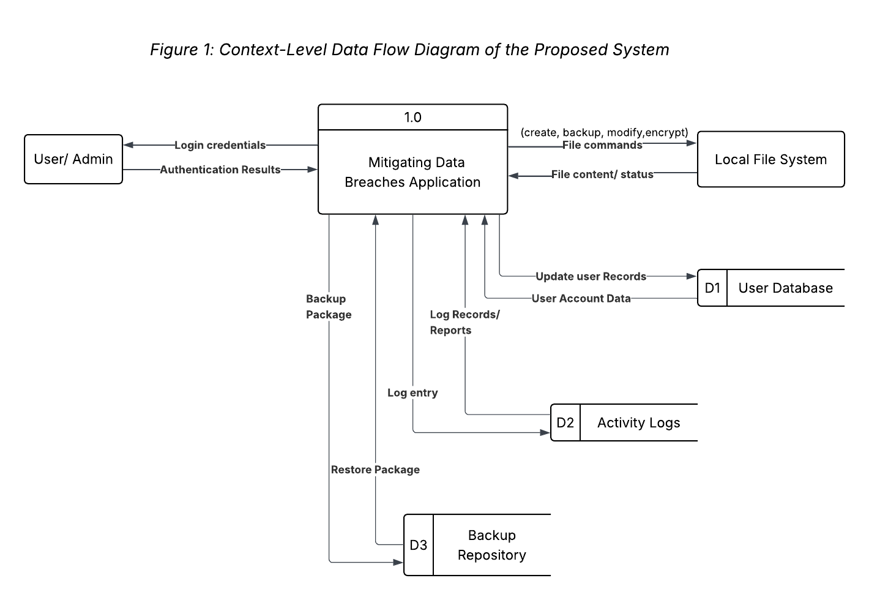
Overall, the DFD illustrated how the system ensured secure file handling and continuous monitoring, which played a vital role in mitigating data breaches.

Entity Relationship Diagram (ERD)

The Entity Relationship Diagram (ERD) illustrated the structural design of the “Mitigating Data Breaches” system. It showed how the User entity was connected to files and activities, ensuring accountability for every action performed. The File entity represented all stored and managed files, which were linked to both Activity Logs for monitoring and Backups for recovery. The diagram emphasized the relationships among users, files, logs, and backups, demonstrating how the system maintained secure file handling, traceability, and data protection to mitigate data breaches.

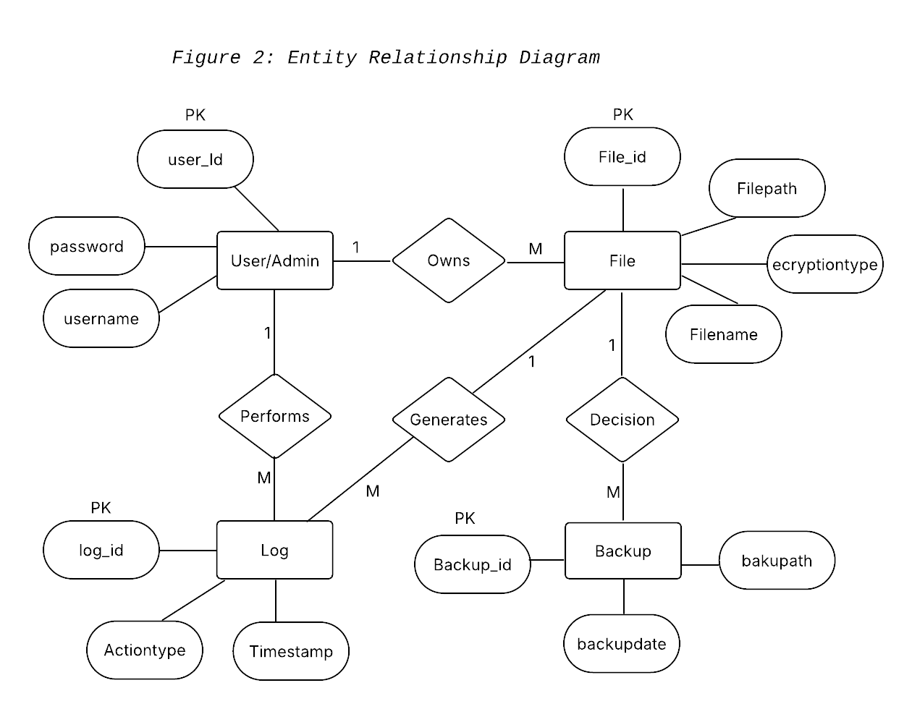

Chapter 4

Result and Discussion

The developed system entitled “Mitigating Data Breaches” successfully achieved its objective of enhancing file security and protecting data from unauthorized access and accidental loss. The system’s integrated features such as file monitoring, encryption and decryption, automated and manual backup, log scanning, machine learning–based anomaly detection, IP tracking, and real-time alert notifications worked together to detect and respond to potential data breaches effectively. The testing results showed that the system accurately recorded file activities, detected suspicious behavior, and promptly notified users or administrators through its alert mechanism. Users who evaluated the system found it functional, reliable, and easy to use, particularly appreciating the real-time monitoring and automatic notification capabilities. Although challenges were encountered during implementation, such as optimizing performance and refining the machine learning model, the overall results confirmed that the system was an effective and practical tool for securing files and mitigating data breach risks in a local desktop environment.

System’s Features

The developed system entitled “Mitigating Data Breaches” consisted of several integrated features designed to protect digital files and prevent unauthorized access. Each module worked together to ensure the confidentiality, integrity, and availability of data within a local desktop environment. The following are the main features of the system:

- File Monitoring Module
This feature continuously tracked all file activities such as creation, modification, deletion, movement, and encryption. It provided users and administrators with detailed logs of every file operation, enabling the detection of unauthorized or suspicious activities in real time.
- Encryption and Decryption Module
This module ensured that sensitive data remained secure by encrypting files using a cryptographic algorithm. Only authorized users were able to decrypt and access protected files, maintaining the confidentiality of information even if data were compromised.
- Backup and Recovery Module
The system included both automated and manual backup functions that allowed users to restore lost or corrupted files easily. This feature helped preserve file availability and minimized the risk of permanent data loss caused by accidental deletion or security breaches.
- Log Scanning and Reporting Module
This component generated comprehensive records of user activity and system events. The logs could be reviewed by administrators to identify irregular patterns or potential security threats, supporting early detection and investigation of breach attempts.
- Machine Learning–Based Anomaly Detection
A built-in machine learning model analyzed patterns of user behavior and file activity to detect unusual actions that might indicate a data breach. This intelligent feature enhanced the system’s ability to recognize potential threats automatically and strengthened overall protection.
- IP Tracking Module
This feature monitored network connections and tracked IP addresses accessing the system. It helped identify remote or unfamiliar access attempts that could pose a risk to file security.
- Real-Time Alert Notification
The alert system immediately notified users or administrators whenever suspicious behavior or unauthorized access was detected. These instant alerts enabled quick responses, minimizing potential damage and data exposure.

Implementation Challenges

During the development and implementation of the “Mitigating Data Breaches” system, several challenges were encountered that affected the design, integration, and optimization of its features. One of the main challenges was the integration of machine learning for anomaly detection. Training the model to accurately distinguish between normal and abnormal file activities required extensive testing and adjustment of datasets to reduce false detections. Another difficulty involved performance optimization, as continuous file monitoring and logging processes initially caused delays in system response. The researchers addressed this by refining the code structure and optimizing resource usage to maintain smooth operation.

The implementation of encryption and decryption also presented challenges, particularly in managing encryption keys and ensuring that the process remained secure without affecting usability. Likewise, the IP tracking and alert notification system required reliable network handling to prevent false alerts and ensure real-time detection of suspicious access. Additionally, designing an intuitive graphical user interface (GUI) that balanced security and user convenience proved challenging, as the system had to remain both functional and accessible to non-technical users.

Despite these challenges, the researchers successfully overcame the issues through continuous testing, code optimization, and user feedback. The resulting system functioned effectively, demonstrating its capability to detect, prevent, and mitigate data breaches in a local desktop environment.

User Feedback
This section presents the feedback gathered from users who evaluated the developed system entitled “Mitigating Data Breaches.” The purpose of this evaluation was to assess the system’s usability, functionality, security, performance, and overall effectiveness in protecting files against unauthorized access and data loss.
A total of 30 respondents participated in the evaluation of the system. The respondents were composed of:
- 21 Students (70%)
- 9 General Computer Users / IT-related individuals (30%)
All respondents had basic knowledge of computer usage and were able to interact with the system during testing.
User feedback was collected using a structured questionnaire based on a 5-point Likert scale. Respondents evaluated the system after using its key features such as file monitoring, encryption, backup, and alert notifications.
Scale Used:
5 – Strongly Agree
4 – Agree
3 – Neutral
2 – Disagree
1 – Strongly Disagree
The weighted mean was used to analyze the responses and determine the level of user satisfaction.
The evaluation focused on the following areas:
- Usability
- Functionality
- Security
- Performance
- Overall Satisfaction
Criteria | Mean | Interpretation
Usability | 4.50 | Strongly Agree
Functionality | 4.40 | Agree
Security | 4.60 | Strongly Agree
Performance | 4.25 | Agree
Overall Satisfaction | 4.55 | Strongly Agree
Overall Mean | 4.46 | Strongly Agree

Usability – 90% satisfied
Functionality – 88% satisfied
Security – 92% satisfied
Performance – 85% satisfied
Overall Satisfaction – 91% satisfied

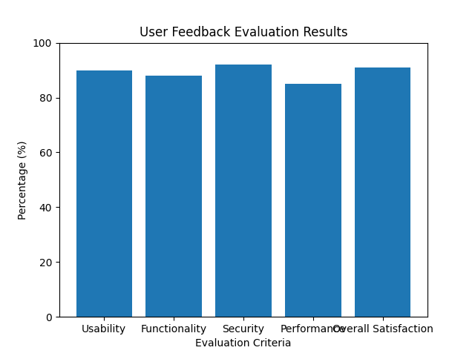
Figure 3: User Feedback Evaluation Graph
Users provided generally positive feedback regarding the system. Many respondents appreciated the following features:
- Real-time file monitoring
- Alert notification system
- Encryption and backup functionalities
Some sample responses include:
- “The system is easy to use and helpful in monitoring files.”
- “The alert feature is very useful for detecting suspicious activity.”
However, several users suggested improvements such as:
- Improving system speed during continuous monitoring
- Simplifying advanced features for non-technical users
- Adding tutorials or user guides
The results indicate that the system achieved a high level of user acceptance, with an overall mean of 4.46 (Strongly Agree). This shows that users found the system effective, reliable, and user-friendly.
The highest rating was observed in security (4.60), confirming that users trust the system’s ability to protect files. Meanwhile, performance (4.25) received the lowest rating, suggesting the need for further optimization.
Overall, the system successfully met its objectives of mitigating data breaches while maintaining usability.
Based on the evaluation, the “Mitigating Data Breaches” system is a functional, reliable, and effective solution for securing digital files. The positive feedback confirms that the system enhances data protection and provides a user-friendly experience.
The suggestions provided by users will serve as a basis for future improvements to further enhance system performance and usability.

Comparison to other System

In comparison to existing file management and security systems, the developed application “Mitigating Data Breaches” demonstrated superior functionality and integration of security features. Traditional file explorers, such as those built into operating systems, primarily focused on basic file management tasks like creating, moving, and deleting files. However, they lacked advanced security capabilities such as real-time monitoring, encryption, and automated backup. Similarly, most antivirus or third-party security tools were designed mainly to detect and remove malware rather than to monitor user file activity or prevent data breaches caused by human error or unauthorized access.

The “Mitigating Data Breaches” system addressed these limitations by combining both file management and cybersecurity features in a single application. It offered real-time file monitoring, encryption and decryption, log scanning, and automated backup and recovery, which enhanced file protection beyond what typical file managers could provide. Moreover, the system incorporated machine learning based anomaly detection and IP tracking, allowing it to identify suspicious patterns of behavior and possible remote access attempts. These intelligent functions were not commonly found in traditional security software, which often relied solely on signature-based detection.

Another distinguishing feature of the system was its real-time alert notification module, which immediately informed users or administrators of potential threats. This proactive approach significantly improved the response time to security incidents compared to other systems that only generated reports after a breach occurred. Through these innovations, “Mitigating Data Breaches” proved to be a more comprehensive, adaptive, and user-friendly solution for ensuring data confidentiality, integrity, and availability in a local desktop environment.

Chapter 5

Conclusion and Recommendation

This study focused on the development of a desktop-based security application entitled “Mitigating Data Breaches.” The system was designed to address the growing risks of unauthorized access, accidental data loss, and weak file protection in local computer environments. It integrated various modules such as file monitoring, encryption and decryption, automated and manual backup, log scanning, machine learning based anomaly detection, IP tracking, and real-time alert notifications. Using the Developmental Research Design under the Agile Software Development Life Cycle (SDLC), the researchers successfully planned, designed, implemented, and evaluated the system. Results from user testing revealed that the system effectively improved data protection, ensured file integrity, and enhanced user awareness against potential security threats.

Conclusion

Based on the findings of the study, the “Mitigating Data Breaches” system successfully achieved its objectives of detecting, preventing, and mitigating data breaches in a local desktop environment. The system provided a secure and user-friendly platform that allowed users to manage files safely while monitoring real-time activities for possible breaches. The integration of machine learning and IP tracking made the system more intelligent and responsive compared to conventional file management tools. Furthermore, the inclusion of automated alerts and backup functions strengthened the system’s reliability and proactive defense mechanisms.

The study concluded that combining traditional file management with advanced security measures such as encryption, anomaly detection, and alert notifications significantly enhances the protection of digital assets. Despite minor challenges during development such as optimizing performance and refining machine learning accuracy the overall system proved to be functional, efficient, and practical for personal and institutional use.

Recommendation

Based on the development and evaluation of the project, the following recommendations are made:

- System Enhancement
Future versions of the system may include multi-factor authentication, cloud synchronization, and role-based access control to strengthen data protection and expand accessibility.
- Improved Machine Learning Model
The anomaly detection module may be enhanced through larger datasets and additional training to improve accuracy in identifying complex threat patterns.
- Broader Implementation:
The system may be deployed in organizational or institutional settings to evaluate its performance in multi-user environments.
- User Training
Regular orientation or tutorials for users are recommended to ensure that they understand the proper use of encryption, backup, and alert features.
- Further Research
Future studies may explore the integration of network-level intrusion detection and real-time cloud monitoring to make the system adaptable to larger-scale cybersecurity applications.

Final Thoughts

The completion of this study and the development of the “Mitigating Data Breaches” system underscored the importance of integrating technology, innovation, and cybersecurity awareness in protecting digital information. Through the combination of monitoring, encryption, backup, anomaly detection, and real-time alerts, the system provided a proactive solution to the persistent issue of data breaches. More than a technical achievement, this project represented a step toward promoting digital responsibility and strengthening user awareness of data security. The researchers realized that mitigating data breaches is not only a matter of developing software but also fostering a culture of vigilance, accountability, and continuous improvement. Ultimately, the project proved that even in a local environment, intelligent security measures can make a significant impact in ensuring the confidentiality, integrity, and availability of information.

Appendices

Appendix A: System Interface Screenshots
- Login Page
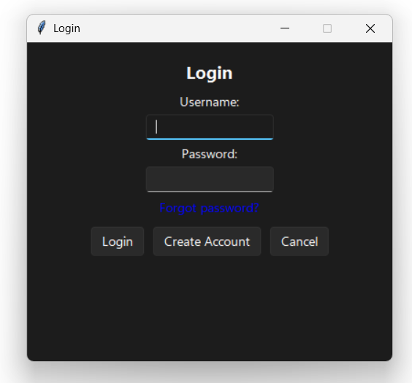

- File_Explorer
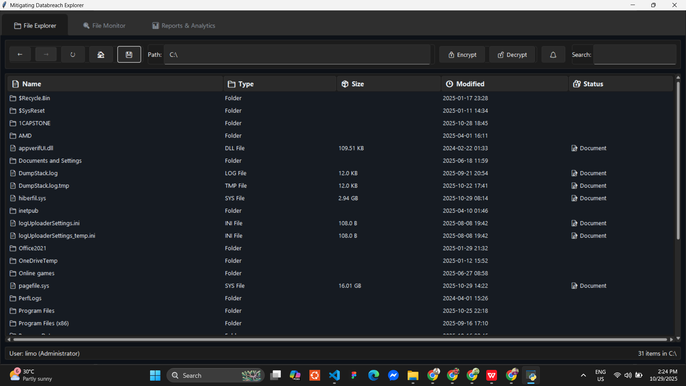

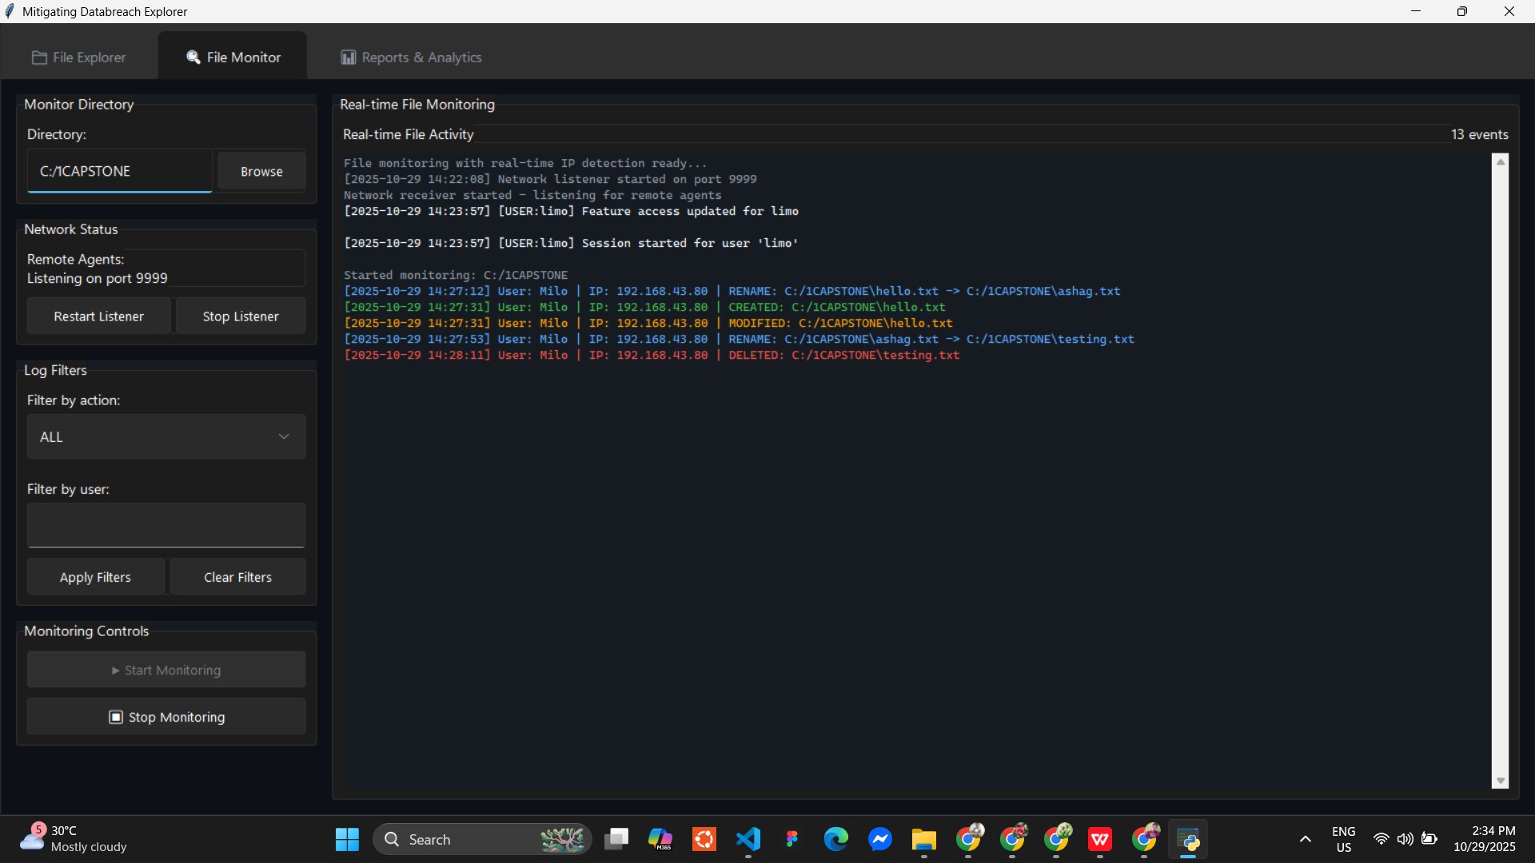
- File Monitoring

Analytics And Reports
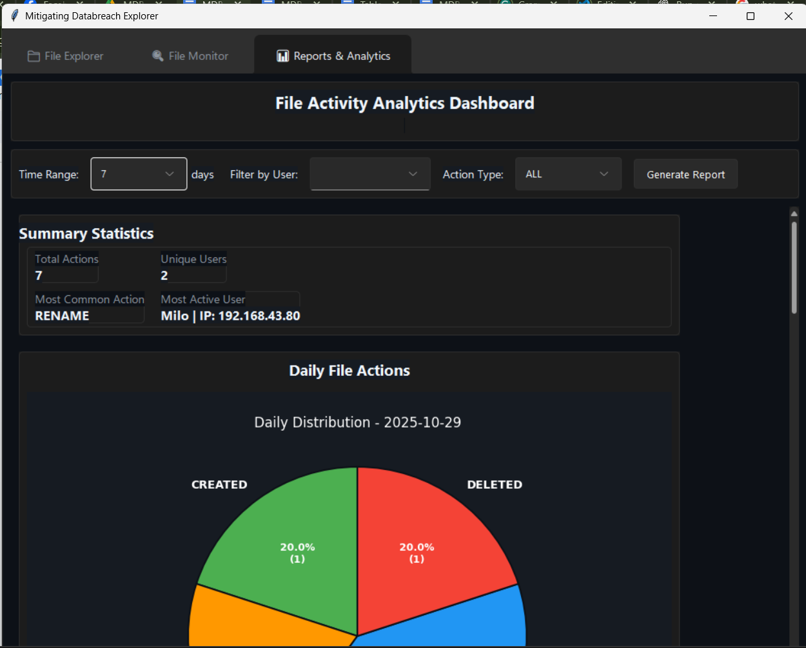

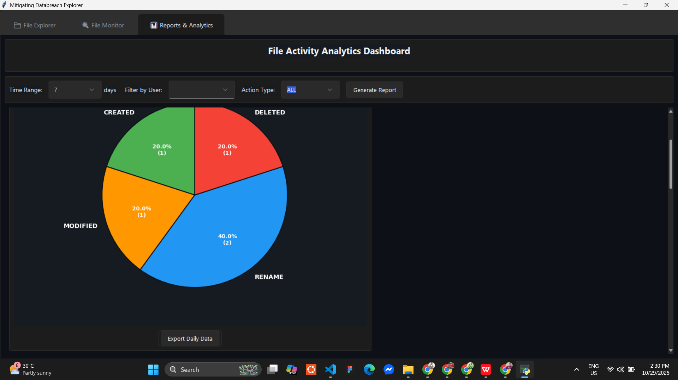

Appendix B: Data Flow Diagram

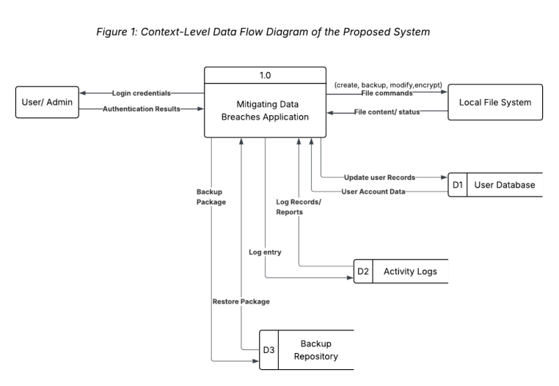

The DFD illustrated how the system ensured secure file handling and continuous monitoring, which played a vital role in mitigating data breaches.

Appendix C: Entity Relationship Diagram
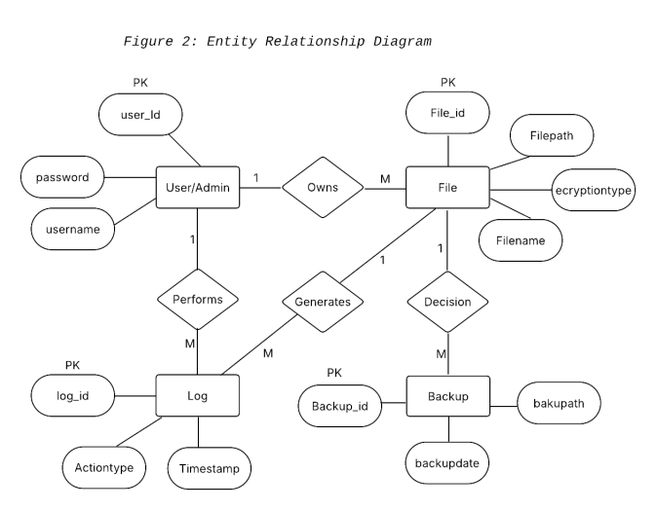

The diagram emphasized the relationships among users, files, logs, and backups, demonstrating how the system maintained secure file handling, traceability, and data protection to mitigate data breaches.
Code impression management
Python: imports
-tkinter
import os
import tkinter as tk
from tkinter import ttk, filedialog, messagebox, scrolledtext
import json
import time
from datetime import datetime
import pandas as pd
from watchdog.observers import Observer
from watchdog.events import FileSystemEventHandler
import getpass
import csv
import re
import socket
import psutil
import threading
import subprocess
import requests

# === Socket server imports and configuration ===
import socketserver
import threading
from typing import Dict, Any
# Configuration for the network listener
LISTENER_PORT = 9999 # Port for receiving events from remote agents
LISTENER_HOST = '0.0.0.0' # Listen on all network interfaces
# === END NEW ===

logging_enabled = True
_logging_lock = threading.Lock()

def set_logging_enabled(state: bool):
"""Enable or disable file activity logging globally (thread-safe)"""
global logging_enabled
with _logging_lock:
logging_enabled = state
status = "ENABLED" if state else "DISABLED"
print(f"🔧 [LOGGING CONTROL] File activity logging: {status}")

# Add a small delay to ensure the setting propagates
import time
time.sleep(0.1)

def is_logging_enabled():
"""Check if logging is enabled (thread-safe)"""
with _logging_lock:
return logging_enabled

Python: file_monitoring.py
class FileMonitorApp:
def __init__(self, root):
self.root = root
self.root.title("File Monitor with Network Integration")
self.root.geometry("1200x700")
self.root.configure(bg=DARK_BG)

# Apply modern styling
self.setup_styles()

# Create notebook for tabs
self.notebook = ttk.Notebook(root, style="Dark.TNotebook")
self.notebook.pack(fill=tk.BOTH, expand=True, padx=10, pady=10)

# Create file monitor tab
self.file_monitor_tab = FileMonitorTab(self.notebook, self)
self.notebook.add(self.file_monitor_tab, text="📁 File Monitor")

# Start the application
self.root.after(100, self.on_app_start)

def setup_styles(self):
"""Configure modern dark theme styles"""
style = ttk.Style()

# Configure dark theme
style.theme_use('clam')

# Configure colors for different styles
style.configure("Dark.TFrame", background=DARK_BG)
style.configure("Card.TFrame", background=DARK_CARD)
style.configure("Card.TLabel", background=DARK_CARD, foreground=TEXT_PRIMARY)
style.configure("Secondary.TLabel", background=DARK_CARD, foreground=TEXT_SECONDARY)

# Configure notebook
style.configure("Dark.TNotebook", background=DARK_BG, borderwidth=0)
style.configure("Dark.TNotebook.Tab",
background=DARK_CARD,
foreground=TEXT_SECONDARY,
padding=[15, 5])
style.map("Dark.TNotebook.Tab",
background=[("selected", DARK_HOVER)],
foreground=[("selected", TEXT_PRIMARY)])

# Configure buttons
style.configure("Modern.TButton",
background=DARK_CARD,
foreground=TEXT_PRIMARY,
borderwidth=0,
focuscolor="none",
padding=[10, 5])
style.map("Modern.TButton",
background=[("active", DARK_HOVER), ("pressed", DARK_HOVER)],
foreground=[("active", TEXT_PRIMARY)])

# Configure entries
style.configure("Modern.TEntry",
fieldbackground=DARK_CARD,
foreground=TEXT_PRIMARY,
borderwidth=1,
relief="flat")
(rest of the codes…)

Python: file_explorer
class FileExplorer(tk.Tk):
def __init__(self):
super().__init__()
self.withdraw()

# user properties
self.current_user = None
self.is_admin = False
self.auth_data = None

# navigation history
self.history = []
self.history_index = -1

# initialize current_path with a default value first
self.current_path = os.path.expanduser("~")

# initialize backup manager
self.backup_manager = BackupManager(main_app=self)

# apply modern dark theme
sv_ttk.set_theme("dark")

Css: styles
# define color scheme
self.bg_color = DARK_BG
self.card_color = DARK_CARD
self.hover_color = DARK_HOVER
self.primary_color = ACCENT_BLUE
self.secondary_color = ACCENT_GREEN
self.accent_red = ACCENT_RED
self.text_primary = TEXT_PRIMARY
self.text_secondary = TEXT_SECONDARY

# Custom fonts
self.title_font = Font(family="Segoe UI", size=11, weight="bold")
self.main_font = Font(family="Segoe UI", size=10)
self.small_font = Font(family="Segoe UI", size=9)
self.mono_font = Font(family="Cascadia Code", size=9)

# path and status variables
self.path_var = tk.StringVar()
self.status_var = tk.StringVar(value="Ready")
self.search_var = tk.StringVar()
self.filter_var = tk.StringVar(value="ALL")
self.filter_action_var = tk.StringVar(value="ALL")
self.filter_user_var = tk.StringVar()

# original initialization
self.title("Mitigating Databreach Explorer")
self.geometry("1200x800")
self.configure(bg=self.bg_color)
self.minsize(1000, 700)

# initialize backup directory with default value
self.backup_directory = os.path.join(os.path.expanduser("~"), "Backups")

# configure styles
self.configure_styles()

# load configuration BEFORE creating widgets
self.load_configuration()

# initialize widgets
self.create_widgets()
self.create_tabs() # Create all tabs including file monitor
self.report_tab()
self.create_anomaly_detection_tab()

(the rest of the codes…)

Screenshots



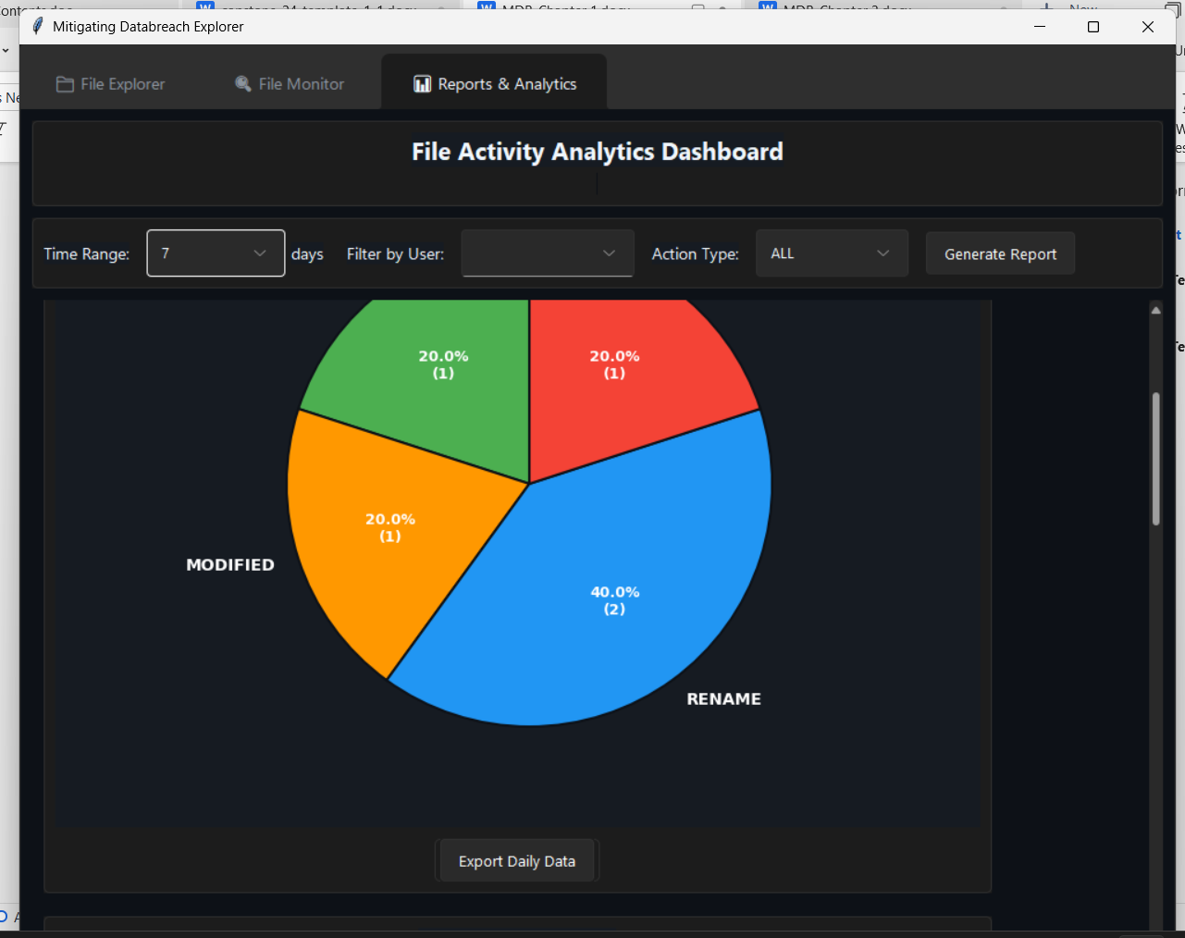


Definition of terms
Activity Logs - Records of all actions done in the system.
Anomaly Detection - Finding unusual or suspicious activities in the system.
Authentication - Checking if a user is allowed to access the system.
Backup - Saving copies of files to prevent data loss.
Confidentiality - Keeping information private and protected.
Data Breach - Unauthorized access to sensitive or private data.
Decryption - Turning encrypted data back into readable form.
Desktop-Based Application - A program that runs on a computer, not on the internet.
Encryption - Protecting data by converting it into an unreadable form.
File Monitoring - Tracking changes made to files.
File Explorer - A tool used to manage and organize files.
Integrity - Ensuring data is correct and not changed improperly.
IP Tracking - Recording the IP address of users accessing the system.
Log Scanning - Checking logs to find suspicious activities.
Machine Learning - A system that learns patterns from data to improve detection.
Real-Time Monitoring - Observing activities as they happen.
Real-Time Alert Notification - Instant alerts when suspicious activity is detected.
Recovery - Restoring lost or deleted files.
Security System - A system that protects data from threats.
System Performance - How fast and smoothly the system works.
User Interface (UI) - The part of the system that users see and use.
Usability - How easy the system is to use.

Curriculum Vitae
Name: Chrislyn A. Limo
Address: Brgy. Tagbac Sur, Oton, Iloilo, Philippines
Contact Number: 0968-655-2926
Email: lmchrislyn@mail.com
Position Applied: IT Professional

Personal Information
Date of Birth: October 1, 2003
Place of Birth: Barangay Tagbac Sur, Oton
Civil Status: Single
Nationality: Filipino
Languages: English, Filipino

Educational Background
Bachelor of Science and Information Technology
PHINMA University of Iloilo – Iloilo City
2025 – 2026
Senior High School
Oton National High School, Oton, Iloilo
2020-2021

Skills
Good communication skills
Flexibile in work & team collaboration
Soft skills
Miduim skills in Excel, Micrsoft Word
Name: Milo B. Yasa Jr.
Address: Parc Regency Pavia. Phase D - Blk 3 Lot 11
Contact Number: 09497327487
Email: milobyasajr@gmail.com
Position Applied: IT Professional

Personal Information
Date of Birth: August 6, 2001
Place of Birth: Lemery, Iloilo City
Civil Status: Single
Nationality: Filipino
Languages: English, Filipino

Educational Background
Bachelor of Science in Information technology
University of Iloilo Phinma
2021 – 2022
Senior High School
Iloilo City National High School, Molo, IloiloCity
2014 – 2020
Skills:
Communication Skills
Team collaboration
Flexible in work
Organizational

Name: Riben Clark Pulmones Gaspar
Address: Brgy. Jebioc Pototan, Iloilo
Contact Number: 09515572022
Email: ribenclarkgaspar@gmail.com
Position Applied: IT professional

Personal Information
Date of Birth: June 18, 2004
Place of Birth: Pototan Iloilo
Civil Status: Single
Nationality: Filipino
Languages: English, Filipino

Educational Background
Bachelor of Science in Information Technology
University of Iloilo – Iloilo City
2022 – 2026
Senior High School
Zarraga National High School
2020 – 2021

Skills:
Excel
Python
HTML, CSS

Grammarian Certificate

